**DR. ARVIND VIRMANI**

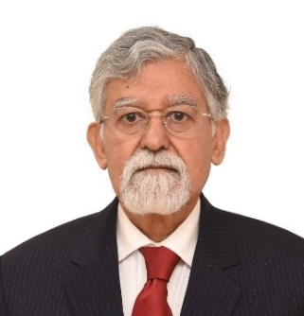

**MEMBER, NITI AAYOG**

Dr. Arvind Virmani is a Member of NITI Aayog. He specialises in policy & institutional reforms for sustained, fast inclusive economic growth.

He is a macro economist who has bridged the gap between academics, think tanks and policy makers, through research based policy advice and policy oriented research. He played a prominent, professional and advisory role in the economic reforms of the 1990s and 2000s, such as Tax, Tariff, Foreign Exchange, Financial Sector & Expenditure Policy reforms.

He was the founder Chairman of the “Foundation for Economic Growth and Welfare” (EGROW) and President of the Forum for Strategic Initiatives (FSI, Delhi) and has earlier served as Executive Director, IMF, Chief Economic Advisor, Ministry of Finance and Principal Advisor, Planning Commission.

He was Director & Chief Executive of ICRIER and has published over 60 Journal Articles, Books & Chapters, and more than 100 Working and Policy Papers in Macroeconomics, Growth, Tax & Tariff Reform, Foreign Exchange, International Relations and National Security Strategy.

He was a member of the TRAI, a mentor (Public Policy & Economics) to FICCI, and Member of Technical Advisory Committee on Monetary Policy, RBI.

His experience in Finance Sector includes: Chairman, Board of Trustees of SBI Mutual Fund, Director LIC, Member of SEBI Appellate Tribunal and Depositories Act, Member Board of Trustee at UTI and Director in PNB, Allahabad Bank and EXIM Bank.

His Think Tank experience includes: Member, Board of Governors in CPR & RIS, Non-resident Sr. Fellow in Brooking Institution, USA, Affiliate Professor & Distinguished Sr. Fellow in George Mason University, USA.

**Personal Websites for Papers, Articles & Blogs:**

Website: <http://sites.google.com/site/dravirmani/>

Repository: [Pre-EGROW Paper | EGROW Foundation](https://egrowfoundation.org/research/pre-egrow-paper/) .

<https://egrowfoundation.org/team/arvind-virmani/>

Blog: <http://dravirmani.blogspot.in/>

|  |  |
| --- | --- |
| **Chintan:** | |
|  |  |
|  | https://sites.google.com/site/chintan1997reg/ |
|  | |
| **Social Media links:** | |
|  |  |
| Facebook - Wikipedia | <https://www.facebook.com/arvindvirmani2/> |
|  |  |
| Twitter - Wikipedia | @dravirmani  <https://twitter.com/dravirmani> |